Smart Adaptive Lane Marking Node (SALMS) – Hardware Prototype- Brandon Early

Simple, Single NODE Setup

Wiring Diagram
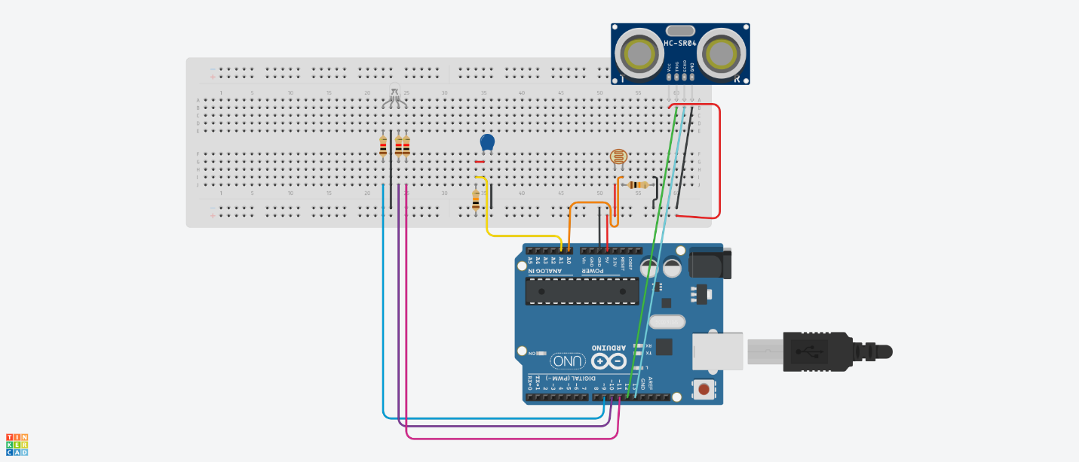
Note: I have depicted the thermistor as a capacitor as Tinker Cad doesn’t have a thermistor in their circuit’s components.

Wiring Setup
This setup shows the initial wiring of a single NODE in the SALMS system. This prototype uses two voltage dividers with 10kΩ resistors to read the voltages of the thermistor and photoresistor. This measurement is fed into pins A0 and A1, which are analog to digital converting pins (ADC), allowing for the measurements to be used in the code. Arduino UNOR3 boards have a 10-bit ADC resolution, this means it can read, and convert up to 5V, which is just fine, as the power source is the 5V pin on the board. Some simple math allows for the ADC reading to be converted to a voltage measurement to be used in the program.
$$Voltage=ADC*\left(\frac{5.0}{1023.0}\right)$$

Using a single RGB LED, we can dynamically change the color/brightness according to the event the sensors are recording. 1kΩ resistors are used to ensure the LED isn’t blown.

Initial Arduino Code
https://github.com/brandonearly/REU_Spring2026
The code itself is well commented and straightforward to understand, but I will provide a short summary of its functionality here. Essentially, this program reads in the values of interest from the sensors, based on ranges found experimentally, and converts them into one ‘normalized’ value between 0 and 1, based on these ranges.
Once the values are all normalized, a weighted average is taken, prioritizing light level and object distance slightly over temperature. I chose to make this prioritization based on my personal expectations of what would most severely affect road/driving safety and conditions (i.e. darkness or objects in the road are generally more dangerous than the air being cold).
The weighted average is then used to dynamically change the brightness of the RGB LED, which I have chosen to make green only, for the sake of this prototype and proof of concept. This is because I found it easier to notice small differences in brightness while the LED was green rather than other colors.
Finally, the normalized values of each sensor, the weighted average, and a ‘state’ variable placeholder for NODE-to-NODE communication are printed to the monitor for data observation.

Initial Results

Ultrasonic Sensor
I implemented an ultrasonic sensor on this version of the prototype to serve as an example motion sensor that may be used in more polished versions of the project to detect moving cars, pedestrians, animals, etc. on the roadway. This sensor, while good enough for the purposes of this prototype, is wildly inconsistent, especially as the distance from the object of interest scales. As a result of this, the effective range I am tracking is merely 0 to 5 cm from the sensor. After many tests, distances much farther than that had inconsistent results and effects on the brightness calculation. The pictures below show the difference in brightness on the LED when an object, in this case a flashlight, is placed at different distances from the sensor.
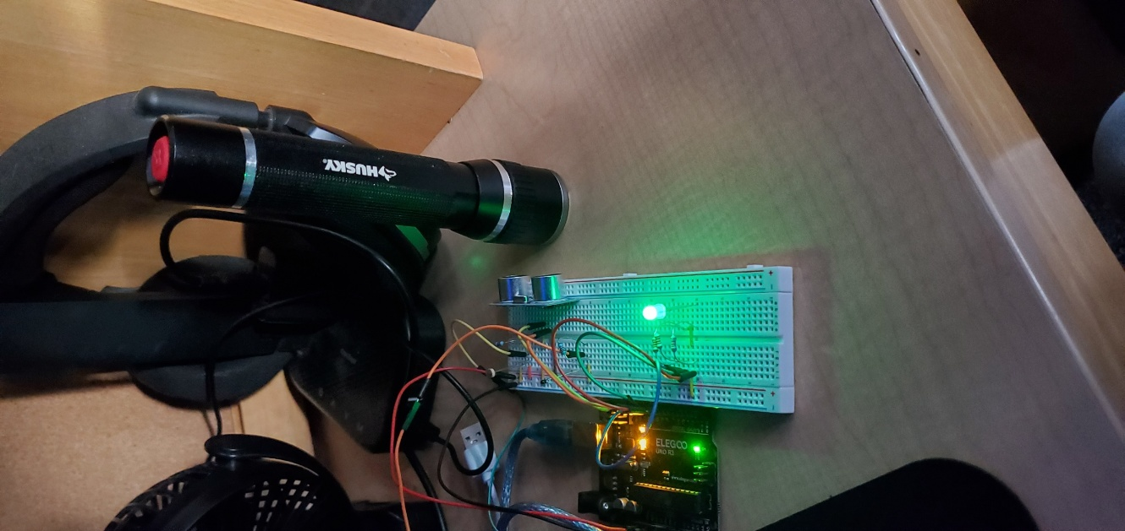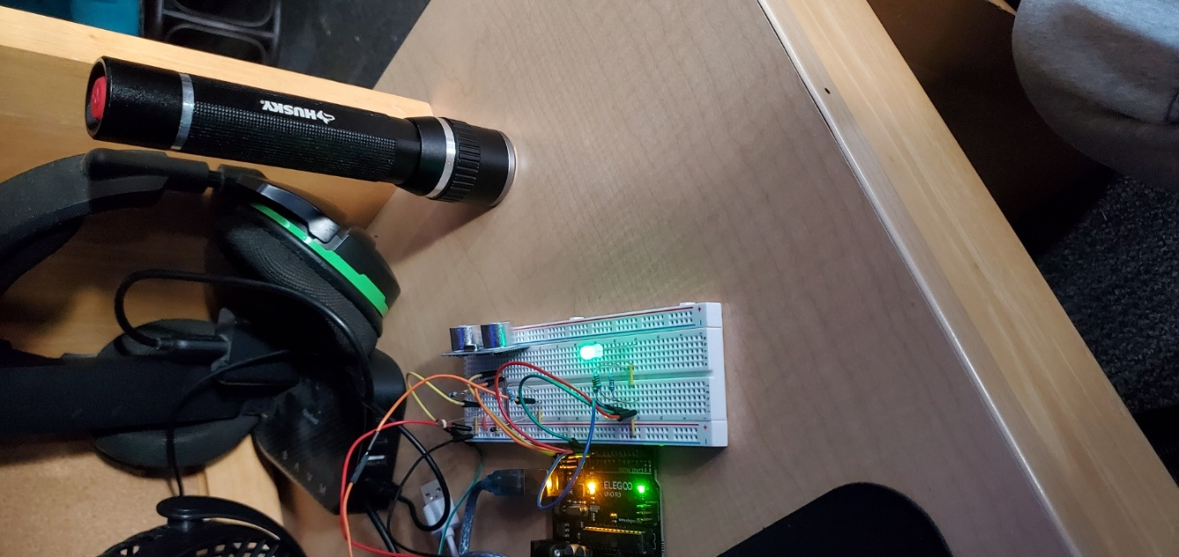

Photoresistor
I implemented a photoresistor on this version of the prototype to serve as an example light sensor that may be used in more polished versions of the project to detect sunlight, visibility or potentially even as a power source in the form of a solar panel. The resistance of the photoresistor I am using in this prototype drops as it is exposed to more light. Based on some experimental trials, I have settled on an effective range of ~.3 V to 4.5 V to represent amount of light the resistor is exposed to. Notably, .3 V was the low end of the readings I was getting in a room too dark to read in. While I got readings closer to 4.5 V while shining a bright light right on the resistor, so there is obviously quite a bit of fluctuation in the light levels this photoresistor can sense. The pictures below show the conditions the resistor was exposed to, as well as the normalized output and its contribution to the average.
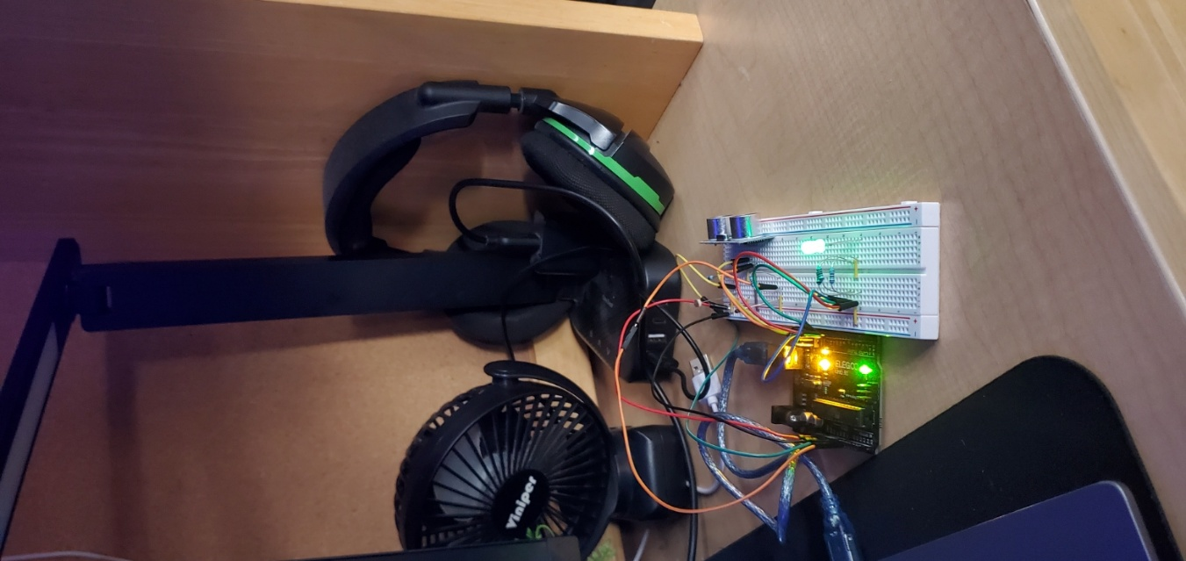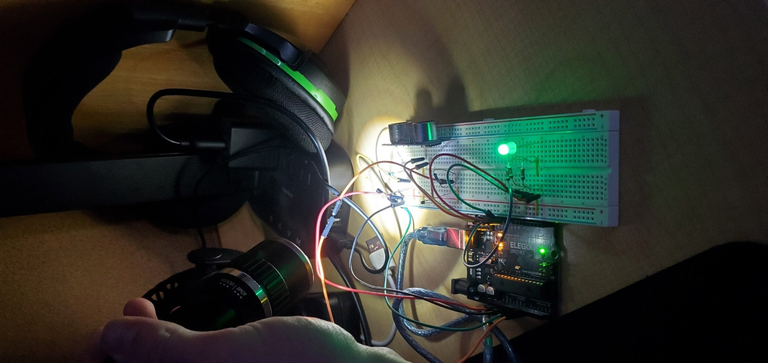
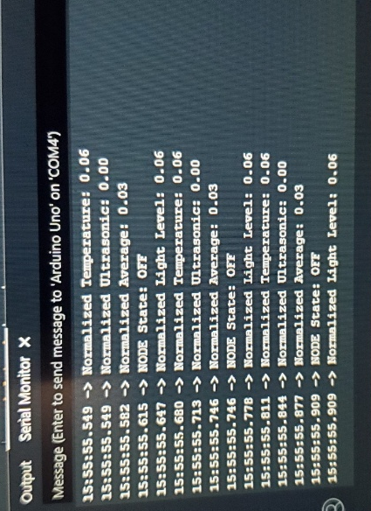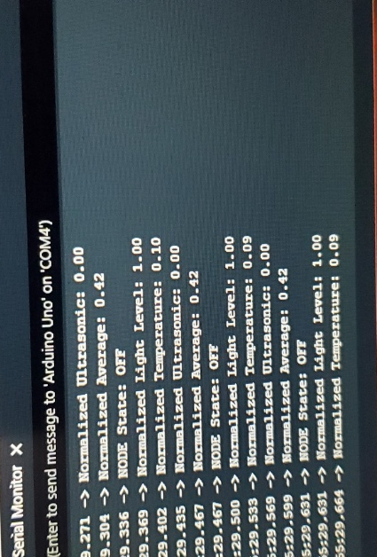

Note that the camera on my phone makes the ‘low light’ environment seem much brighter than it is. Also notice the difference in the normalized contribution from the Light Level in both scenarios, the low light provides just ~.6 out of a potential 1.0 on the normalized scale, while the environment with the flashlight directly on it provides the full 1.0 on the normalized scale. Similarly to the ultrasonic sensor, notice how the LED gets brighter when the flashlight is applied. I did this in consideration of the extra light that is necessary for a NODE on a road in the future to be seen during daytime conditions when it is already quite bright outside.

Thermistor
I implemented a thermistor on this version of the prototype to serve as an example temperature sensor that may be used in more polished versions of the project to detect weather conditions, including snow, ice, sleet, hail, rain or any other potentially temperature related road hazards. The resistance of the thermistor I’ve used in this prototype goes down as the temperature gets colder. Experimental trials led me to choose a range of ~2.6 V to 3.0 V for the thermistor’s normalizing calculation. Admittedly, this sensor is also quite finicky and is easily the most difficult to test, however, I was getting readings of ~2.6 V at room temperature and roughly 3.0 V after holding a plastic bag with ice cubes inside near the thermistor for several seconds. The pictures below show this process, as well as the results I saw.
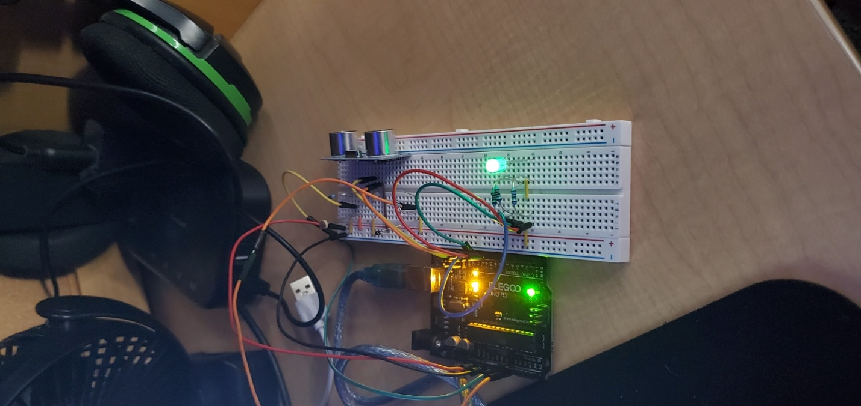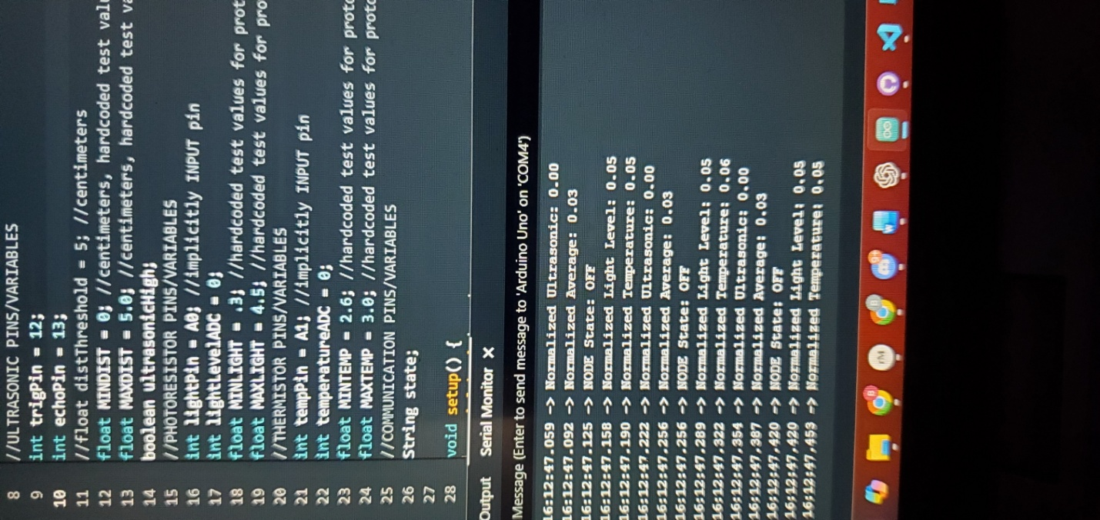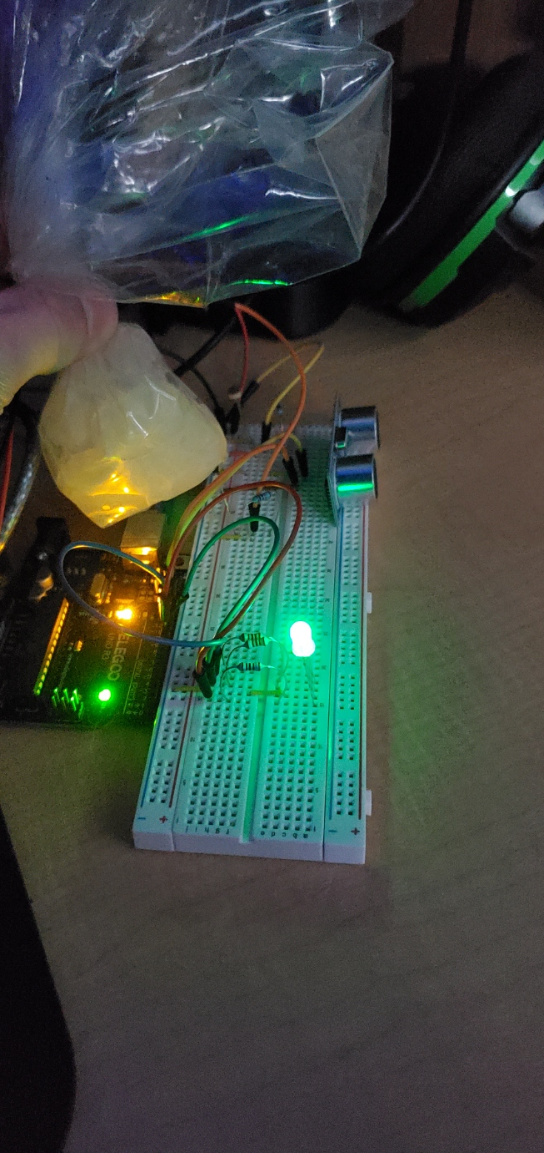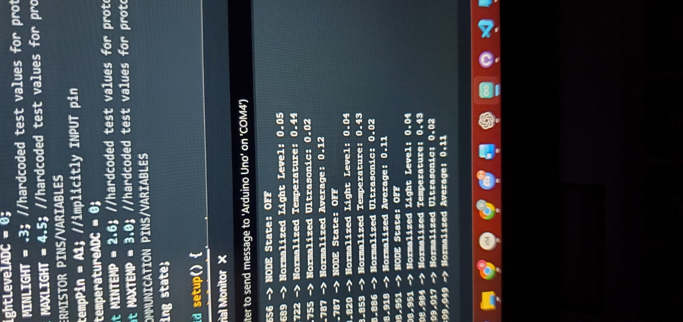

Again, the thermistor was more difficult to do testing with due to the nature of the prototype and the sensor, however it is clear to see that when at room temperature, the contribution from the thermistor is quite low, and the LED is relatively dim. On the other hand, when the bag of ice is placed near the thermistor, the contribution from the thermistor becomes non-negligible and the LED’s brightness increases significantly.

Notes/Future Considerations
- At this stage in the process, I chose to go with the sensors I did for a few reasons:
  - They are cheap, small-scale prototypes of more accurate, useful sensors that would be used on a finished version of the project.
  - I also only have 1 ARDUINO now, so I am working with what I have.
- PIR sensors may be a better/more consistent way of capturing motion inputs than Ultrasonic for future prototypes; I just don’t have PIR sensors to test with.
- More accurate versions or genuine sensors for both light and temperature would also be a considerable upgrade for a finished product, however the proof of concept is undeniable in this prototype.
- While the resistor values for the photoresistor and thermistor were recommended suggestions, the 1kΩ resistors for the LED were just a guess on my part, and are probably a bit conservative for the 5V prototype, but I only have 2 RGB LEDs and I don’t want to blow them.
- Until I get at least one additional Arduino I haven’t implemented any kind of communication in the code, including the wired simple stuff. I still expect communication to be the most challenging part of the project, including this prototype.
  - Also, sending specific sensor measurements through wired communication may be a lot more difficult than would be worth pursuing, however I don’t know that for sure yet, I will investigate it more.
    - Updating neighboring nodes on a node’s state through wired connection should be extremely straightforward though.
  - On the topic of communication and the microcontroller, while wired communication is fine for the prototype, using an ESP32 to control each node, or a similar microcontroller with WIFI wireless capabilities could be the ‘next step’ forward from a communication standpoint.
    - One note is that I know that ESP32’s/WIFI wireless communication is a bit more power intensive, I can do some more research into other options for longer range wireless communication that isn’t as power hungry?
- Another focus I haven’t had the chance to tackle yet is the ‘power saving’ or ‘sleep’ mode, my basic idea for the prototype at least would just be to have the LED ‘time out’ if the weighted average stays below a threshold for long enough, then only turn back on when the threshold is crossed again.
  - On a practical note, I might do some investigation on LED power draw and solar power generation for example, just to see if we truly need a ‘LED OFF’ mode or if just keeping it dim is fine.
- A miscellaneous thought I had while designing this:
  - Regarding State Propagation, where one node communicates its state to its neighbors, how do we handle the edge case of the first node? Because it doesn’t have a previous ‘neighbor’ does that mean it has to be active all the time?
  - From a power saving perspective, it makes sense for a node in the middle to essentially be doing as little as possible and only be active when necessary, however if they are all only activated by another node, wouldn’t we need at least one to always be active?
- Another more miscellaneous thing, but once I can get another Arduino to use as a node, I’ll probably need some wiring as well, I have shorter wires, but .5m is longer than any jumper cable I have.
- I would also really be interested in investigating battery/solar power in some more detail both for the prototype and a more finished product, so I’ll plan to do that at some point.

